DMarks347 – Aug 2025
Sci (ICC) Scalping strategy
13.5 month back test – 128 trades & 1.783 Profit factor
I ran the optimization from July 1, 2024 to Aug 13, 2025
The standard back test table only has 32 trades and is fairly flat…but the longer back test looks good.
Optimized on MNQ1!, hardcoded for 5 minute chart
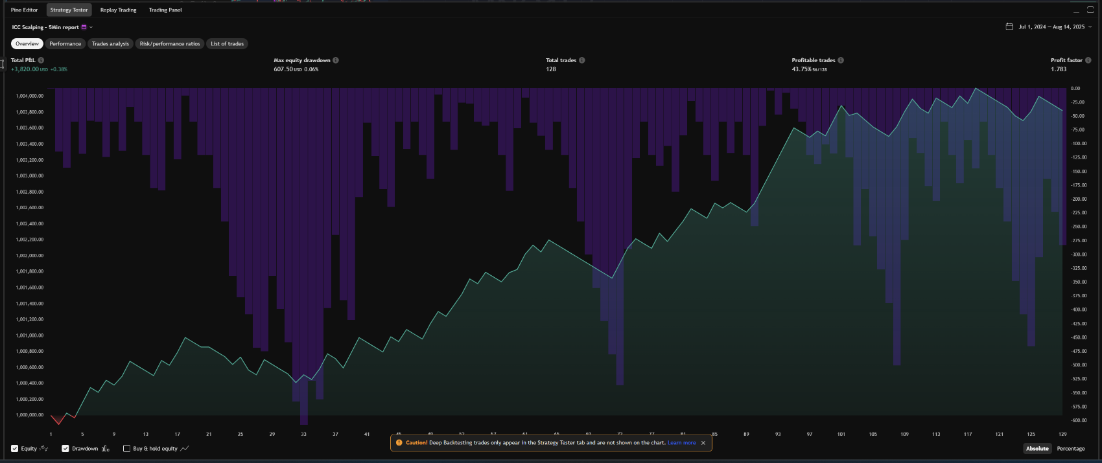
How the strategy works:
The strategy is broken into 4 entry models with various user selections
I draw support and resistance separately for the 2 entry model types
Lots of user entry options to customize and optimize on other assets.
It doesn’t trade every day and clears everything at 14:00 New York time
Entry Model 1 and 2 (EM1, EM2) look for price to be above or below the S&R at open then flow back to that level, take liquidity and then rally back up or fall back down. The user can select touch or close and the minimum distance the price needs to move away from the S&R line to be a valid trade. Example given below for a short, the exact opposite is true for a long.

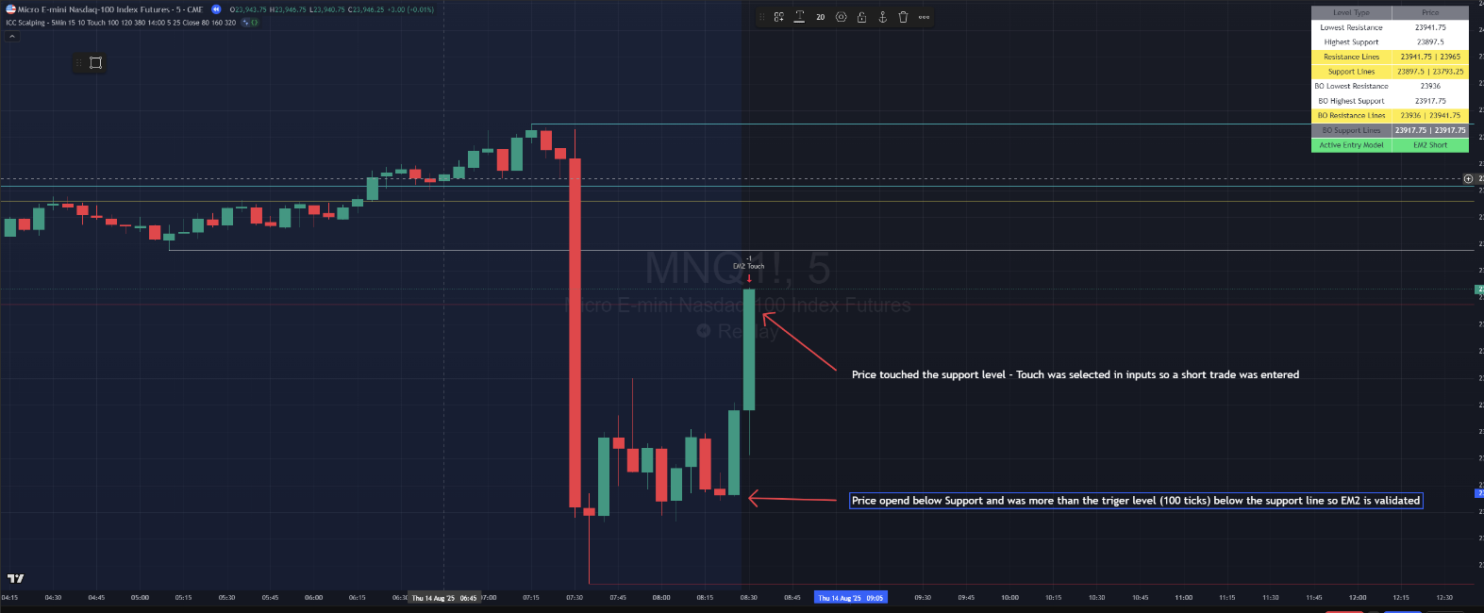
Entry Model 2 Entry, the long version of this would be Entry Model 1

Entry Model 3 and 4 (EM3, EM4) look for price to be trading between S&R at open then breakout, rested and then breakout again. The user can select touch or close and the minimum distance the price needs to move away from the S&R line to be a valid trade. Example given below for a long, the exact opposite is true for a short.
